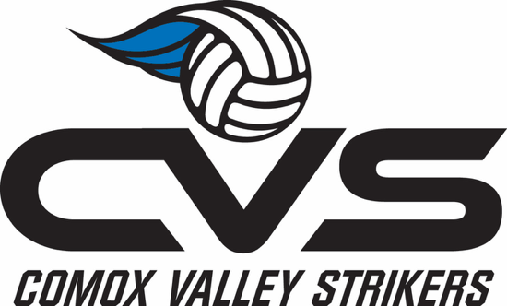
Wave – a more competitive/High-Performance (HP) program

There will be Wave specific try-outs before Strikers try-outs. When you register, only choose Wave (you do not need to register/pay for both try-outs), and you will be asked to check a box if you want to also try out for Strikers (local athletes only) if you do not make a Wave team. Anyone is welcome to try out for the Wave teams – this year we anticipate the teams to be at the 17/18U level.

Cost:
- Club fees for the Wave teams are higher than the Strikers teams, and will cover entry into 2 additional tournaments, including Nationals (plus some of the additional coaching expenses for those tournaments).
- New this 2026 season, club fees will also include extra training, strength training, and sport mentality training.
- There may still be additional tournament and coach expense fees above the amount covered by club fees, depending on how many tournaments the team enters.
- Club fees do not cover travel expenses for any tournaments
  - Travel expenses can be quite high for Nationals (approx. $1,200-$1400 per player?)
- Additional travel expenses will be covered through families & fundraising.

The time commitment for the Wave High-Performance program will be higher:
- 1-2 Strength Training days with training specialist (likely Thursday AM)
- Sport Mentality Training with a sport psychologist

